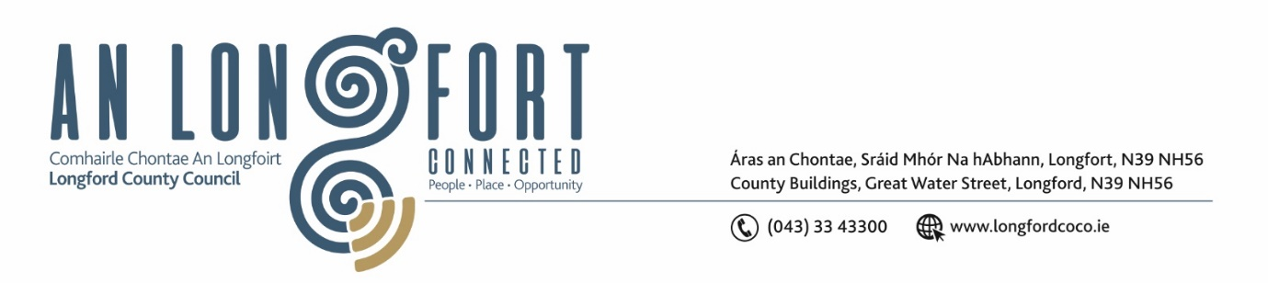

***Please note meeting will be held in the Council Chamber and via Microsoft Teams.***

2 Márta 2023

**Chuig: Gach Ball don Chomhairle**

A Chomhairleoir,

Iarrtar ort bheith i láthair ag Cruinniú Míosuil Chomhairle Chontae Longfoirt a tionólfar i Seomra na Comhairle, Aras an Chontae, Longford agus via MS Teams are an **Chéadaoin 8ú Márta 2023 ag** **4pm** chun gnó a dhéanamh d’réir an Chláir thíos.

You are requested to attend the Monthly Meeting of Longford County Council to be held in the **Council Chamber and via Microsoft Teams** on **Wednesday 8 March 2023 at 4pm** to transact business, as set out on the Agenda hereunder.

Mise le meas,

**__________________**

***Claire McNabola***

***Meetings Administrator.***

**C L Á R**

Prayer before meeting.

**1.** Confirmation of Minutes of Monthly Meeting of Longford County Council held on 15 February 2022 – copy enclosed.

**2.** Matters Arising.

**3.** Declaration of Interest by Members.

**4.** To note Management Report – to follow.

**5.** To note adopted Minutes of Corporate Policy Group Meeting held on the

17 January 2022 – enclosed.

**6. Enterprise and Ukrainian Humanitarian Response**

**(a)** Longford Tourism Strategy 2023 – 2027

**(b)** Notice of Motions, submitted by Councillors, as listed hereunder

**Councillor Garry Murtagh**

Calling on the members of Longford CoCo to write to the Minister for Enterprise to review the rate of Tax PAYE Construction workers are subject too. We are currently experiencing a housing crisis and a shortage of experienced and skilled workers.  This would financially incentivise PAYE construction workers to avail of overtime without been penalised for attaining the same.

**Councillor Garry Murtagh**

Calling on the members of Longford CoCo to write to the Minister for Rural & Community Development, Minister of Finance and the Minister for Enterprise. To promote a pilot scheme in rural Ireland that actually supports a shop local incentive. That would increase footfall and reward loyalty for customers that support one of rural business and small villages, such as shops, pubs, filling stations. These businesses cannot compete with multi-national companies that offer a wide range of special offers, discounts and incentives, including an extensive delivery service that is literally wrenching the heart out of rural Ireland.

**7. Housing, Planning, Regeneration & Capital Projects**

**(a)** To note Planning Applications received since last meeting of the Council.

**8. Community,** **Library and Cultural Services, Corporate and Human Resources**

**(a)** Consideration of representative to the Midland Regional Drug Action Task Force Committee MRDATF to replace Councillor Colm Murray

**9. Infrastructure, Climate Action and Innovation**

1. Consideration of representative to the Longford Westmeath and Roscommon Rural Transport Committee to replace Councillor Pairic Brady
2. Notice of Motions, submitted by Councillors, as listed hereunder:

**Councillor Paul Ross**

I call on Longford County Council to orchestrate a campaign across all local media in relation to the responsibility of dog owners in relation to keeping dogs under control during lambing season as attacks on sheep flocks can have devastating consequences for farmers.

**10. General**

**(a)** Notice of Motions, submitted by Councillors, as listed hereunder

**Councillors - Paul Ross, Gerard Farrell, Colm Murray, Colin Dalton, Pauric Brady, Garry Murtagh, Gerry Hagan, Peggy Nolan, John Browne**

That Longford County Council calls on the Chief Executive to appoint an EU Funding Officer. The role of this officer would be to analyse the Council’s strategic plan and identify where EU funding could be used to progress elements of that plan.

Furthermore, we call on Minister for Housing, Local Government and Heritage Darragh O'Brien to set up a fund to support Local Authorities to access EU Funding.

**Councillor Paul Ross**

1. That Longford County Council call on the Minister for Agriculture to put together a stimulus package for sheep farmers in light of the collapse in sheep prices.
2. That Longford Co Council call on the Minister For Justice to bring in a ‘One for All’ Garda vetting process instead of the current situation in which one individual has to be garda vetted multiple times when involved in different organisations or workplace.

**11.**  **Correspondence**

1. Correspondence dated 2 February 2023 received from the Minister for Transport re. Notice of Motion from Councillor Seamus Butler on the request to meet a representative deputation of Council members to highlight the N4 border improvement plan.

**12. Training – enclosed.**

**13. Votes of Sympathy**